**WHAT IS AGILE**

* Approach to managing and working on projects
* A simple approach to managing complexity

**Sample Projects**

* Software Development
* Managing Service Tickets
* HR new hire process
* Managing a task in a picnic
* Writing a book
* Build a rocket

**CHARACTERISTICS OF AGILE PROJECTS**

**Incremental** – plan, develop, and release increments

**Iterative** – continuously improve the product and the process of building the product

**Focus on Value** –

**Empowered Team** –

**Customer Benefits**

1. Desirable product
2. High quality

**Team Benefits**

1. Higher job satisfaction
2. Better innovation
3. Lower costs
4. Lower risk
5. Predictable deliveries

**SCIENTIFIC METHOD**

1. Create a hypothesis
2. Build an experiment
3. Observe/learn from the results
4. Repeat/iterate

**Waterfall (Simplified)**

* Plan and develop the whole project in phases
* There is an effective **one cycle** of the scientific method

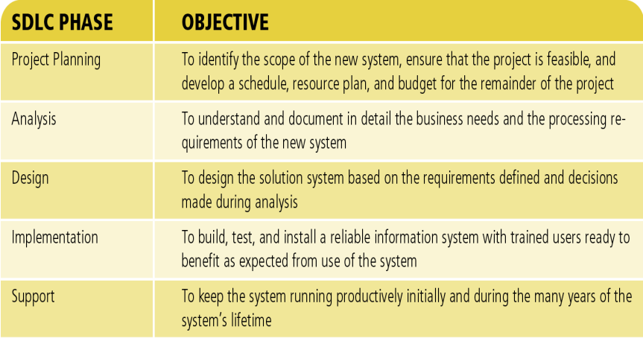

Disadvantages of Waterfall

* You cannot predict the future
* High-value features aren’t correctly identified
* Things are harder, more problematic and take longer to build
* Market and/or team will change while you build
* Change is hard and expensive
* Create a lot of obsolete documents
* Feedback is drastically delayed

Why Waterfall?

* High setup costs
* When work is predictable
* Setup cost of some phases is trending to zero

**Waterfall vs Agile**

|  |  |
| --- | --- |
| Waterfall | Agile |
| * One giant iteration for waterfall | * Many small iterations for agile |
| * Sequential | * Concurrent |
| * One big release | * Many releases |